**WEB DEVELOPMENT MINOR PROJECT**

TOPIC:

WEB PAGE ON HISTORICAL PLACES IN INDIA

PREPARED BY

Allwina Anna Soy Jose

3RD YEAR CSE

SJCET,PALA

18/11/2022

OUTPUT

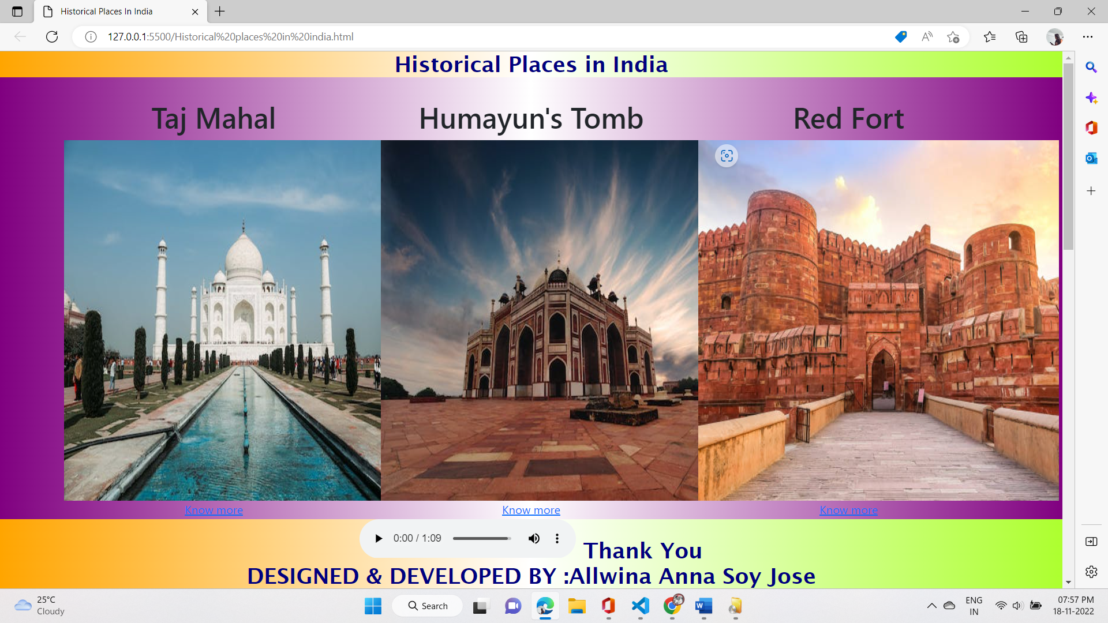

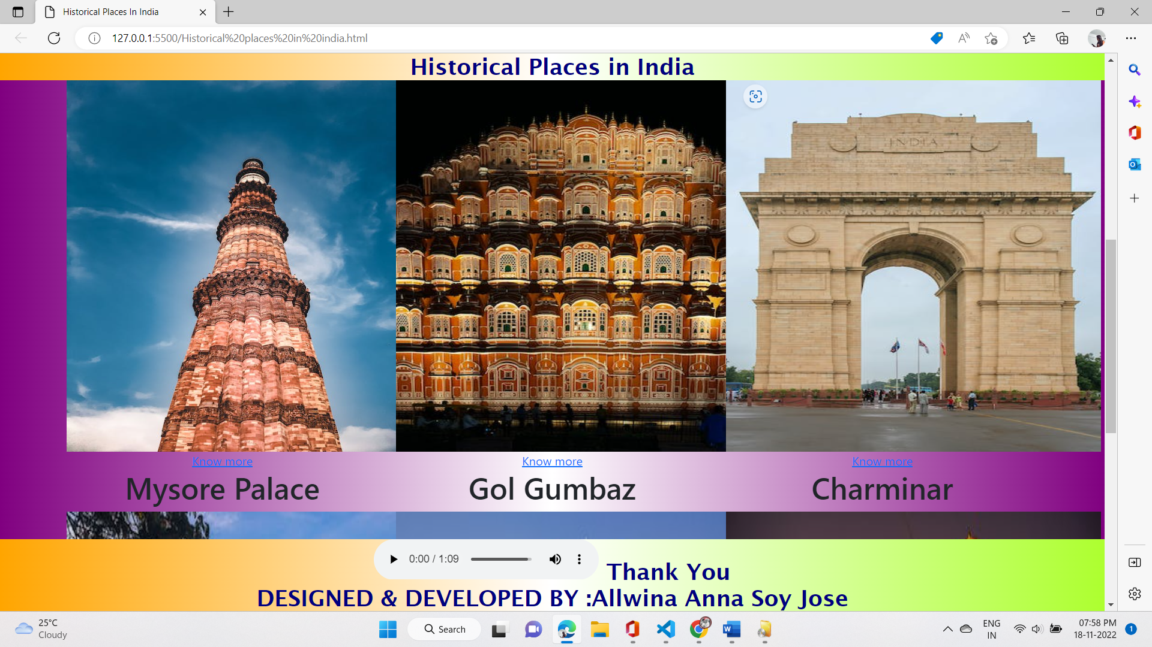

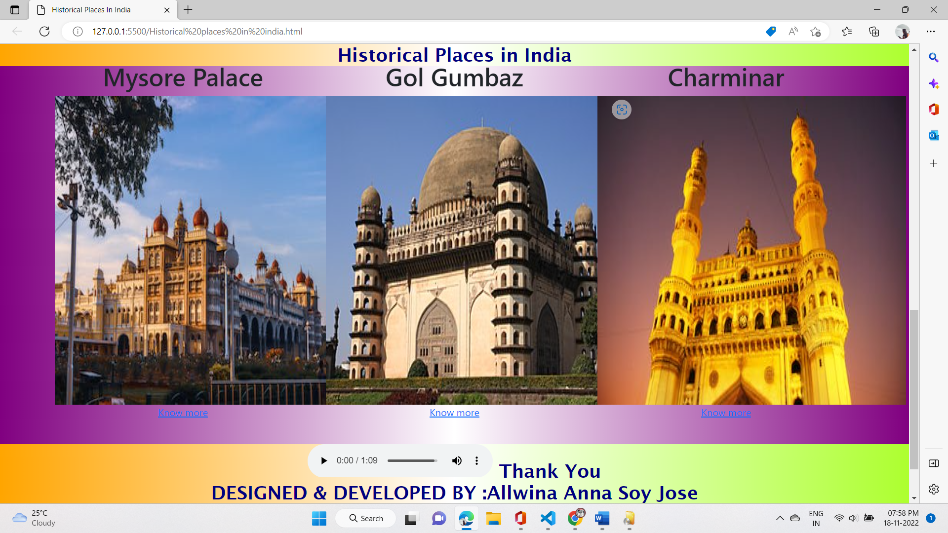

GITHUB: <https://github.com/Allwina/WEB--PAGE>

SOURCE CODE

<!DOCTYPE html>

<html lang="en">

<head>

    <meta charset="UTF-8">

    <meta http-equiv="X-UA-Compatible" content="IE=edge">

    <meta name="viewport" content="width=device-width, initial-scale=1.0">

    <title>Historical Places In India</title>

    <!-- CSS only -->

    <link href="https://cdn.jsdelivr.net/npm/bootstrap@5.2.2/dist/css/bootstrap.min.css" rel="stylesheet" >

<style>

h2{

    width: 100%;

    top: 0px;

    left: 0px;

    background-image: linear-gradient(90deg,orange,white,greenyellow);

    color: navy;

    text-align: center;

    position:fixed;

    font-family: 'Lucida Sans', 'Lucida Sans Regular', 'Lucida Grande', 'Lucida Sans Unicode', Geneva, Verdana, sans-serif;

    font-size: 30px;

}

h3{

    width: 100%;

    bottom: 0px;

    left: 0px;

    background-image: linear-gradient(90deg, orange,white,greenyellow);

    color: navy;

    text-align: center;

    position:sticky;

    font-family: 'Lucida Sans', 'Lucida Sans Regular', 'Lucida Grande', 'Lucida Sans Unicode', Geneva, Verdana, sans-serif;

    font-size: 30px;

}

body{

  background-image: linear-gradient(90deg,purple,white,purple);

}

</style>

</head>

<body>

    <!-- Header -->

    <div class="card">

        <div class="card-header">

            <h2>Historical Places in India</h2>

        </div>

      </div><br><br>

    <!-- grid -->

    <div class="container text-center">

        <div class="row row-cols-3">

          <div class="col">

            <h1> Taj Mahal</h1>

           <img src="https://images.pexels.com/photos/3881104/pexels-photo-3881104.jpeg?auto=compress&cs=tinysrgb&w=600" width="500px" height="500px"  alt=""><br>

           <a href="https://en.wikipedia.org/wiki/Taj_Mahal" target="blank">Know more</a>

          </div><br>

           <!-- Humayun's Tomb -->

          <div class="col">

            <h1>Humayun's Tomb</h1>

            <img src="https://images.pexels.com/photos/1542620/pexels-photo-1542620.jpeg?auto=compress&cs=tinysrgb&w=600"width="500px" height="500px" alt=""><br>

            <a href="https://en.wikipedia.org/wiki/Humayun%27s_Tomb" target="_blank">Know more</a>

           </div><br><br>

         <!-- Red Fort -->

          <div class="col">

            <h1>Red Fort</h1>

            <img src="https://media.istockphoto.com/photos/agra-fort-medieval-indian-fort-at-agra-india-at-sunrise-picture-id1169495248?b=1&k=20&m=1169495248&s=612x612&w=0&h=ROHh0-W8h-e-Tj40cjX625JQowlLT6Tubopbp9l5-7w=" width="500px" height="500px"alt=""><br>

            <a href="https://en.wikipedia.org/wiki/Red_Fort" target="_blank">Know more</a>

           </div><br>

           <!-- Qutub Minar -->

           <div class="col">

            <h1>Qutub Minar</h1>

            <img src="https://images.pexels.com/photos/13385089/pexels-photo-13385089.jpeg?auto=compress&cs=tinysrgb&w=600" width="500px" height="500px" alt=""><br>

            <a href="https://en.wikipedia.org/wiki/Qutb_Minar" target="_blank">Know more</a>

            </div>

            <!-- Hawa Mahal -->

            <div class="col">

                <h1> Hawa Mahal</h1>

               <img src="https://images.pexels.com/photos/9902399/pexels-photo-9902399.jpeg?auto=compress&cs=tinysrgb&w=400" width="500px" height="500px"  alt=""><br>

               <a href="https://en.wikipedia.org/wiki/Hawa_Mahal" target="blank">Know more</a>

              </div><br>

               <!-- India Gate -->

              <div class="col">

                <h1>India Gate</h1>

                <img src="https://images.pexels.com/photos/13819269/pexels-photo-13819269.jpeg?auto=compress&cs=tinysrgb&w=400"width="500px" height="500px" alt=""><br>

                <a href="https://en.wikipedia.org/wiki/India_Gate" target="_blank">Know more</a>

               </div><br><br>

             <!-- Mysore Palace -->

              <div class="col">

                <h1>Mysore Palace</h1>

                <img src="https://images.pexels.com/photos/5480518/pexels-photo-5480518.jpeg?auto=compress&cs=tinysrgb&w=400" width="500px" height="500px"alt=""><br>

                <a href="https://www.google.com/url?sa=t&rct=j&q=&esrc=s&source=web&cd=&cad=rja&uact=8&ved=2ahUKEwignqLgnP76AhWI4XMBHeCbC1QQFnoECBAQAQ&url=https%3A%2F%2Fen.wikipedia.org%2Fwiki%2FMysore_Palace&usg=AOvVaw2epVBXMet2zJ6TEYnJ9TxS" target="_blank">Know more</a>

               </div><br>

               <!-- Gol Gumbaz -->

               <div class="col">

                <h1>Gol Gumbaz</h1>

                <img src="https://upload.wikimedia.org/wikipedia/commons/thumb/0/0c/Gol_Gumbaj2.JPG/330px-Gol_Gumbaj2.JPG" width="500px" height="500px" alt=""><br>

                <a href="https://en.wikipedia.org/wiki/Gol_Gumbaz" target="_blank">Know more</a>

                </div>

                 <!-- Charminar -->

               <div class="col">

                <h1>Charminar</h1>

                <img src="https://images.pexels.com/photos/5491756/pexels-photo-5491756.jpeg?auto=compress&cs=tinysrgb&w=400" width="500px" height="500px" alt=""><br>

                <a href="https://en.wikipedia.org/wiki/Charminar" target="_blank">Know more</a>

                </div>

        </div>

    </div><br><br><br><br><BR></BR>

    <!-- Footer -->

     <h3> <audio src="https://ia800304.us.archive.org/15/items/jana-gana-mana/jana_gana_mana.mp3" controls></audio> Thank You <br>

     DESIGNED & DEVELOPED BY :Allwina Anna Soy Jose</h3>

</body>

</html>

THANK YOU